**PATIENT CONTROLLED ANALGESIA (PCA)**

Generally recommended for patients 6 yrs & older. However, it is important to assess the individual child’s cognitive maturity ~ PCA can even be used in a mature 5 yr old.

Prerequisites :

* + Understand the concept of analgesia upon demand (to press for it)
* Able to cope with latency of onset & mandatory lockout for safety.
* Physically able to press the handset button
* No contra-indications (medical condition /allergies/ cognitive

limitations)

* Parents should be instructed NOT to press PCA for the child

(especially if he/she is sleeping)

PCA pump set up

* + Clear old patient data & select appropriate programme
  + Check that appropriate syringe type / size or cartridge is used (this should last at least 24-48h)
  + Check that settings are appropriate for the drug used & child’s weight

*Compulsory Pump Settings*:

Please programme

* + Bolus
  + Lockout
  + Max. Dose Limit in 1 hour

*Optional Pump Settings*: Loading dose

Background Basal Infusion

Recommended limits are printed on the order form & should not be exceeded

Note that the Lockout time range varies with the opiate profile

with a minimum interval of 5 min for Morphine & 3 min for Fentanyl

Continuous basal infusions are NOT recommended as a routine unless the child is adequately monitored /pain is expected to be severe e.g. scoliosis. Start with 0.5-1.0 ml/h; try not to exceed 1.5 ml/h. Wean the background infusion by 25-50% after 24-48h.

Steps to adhere-to at daily morning round:

1. note total opiate use in 24h (in mg or mcg)
2. note successful vs total demands
3. clear old data & adjust bolus or background as needed
4. check that contents should last at least 24-48h

Dilution:

There are 2 standard ways of diluting the narcotic infusions according to weight: for patients weighing< 50 kg *or*  ≥ 50 kg

All orders must be clearly written, dated & signed

The syringe/cartridges should also be similarly labeled

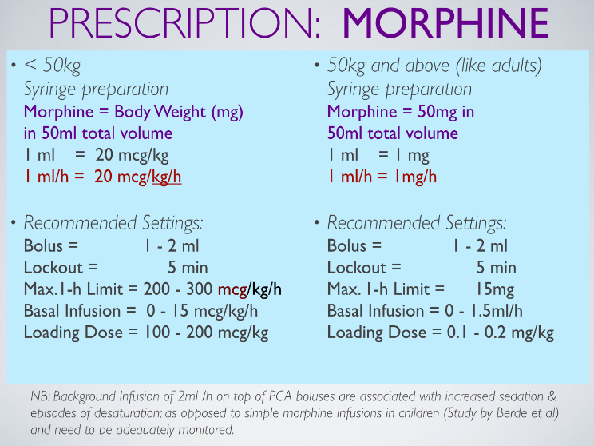

CADD cartridges of various volume capacities (50 ml - 10 ml) require corresponding dilutions to achieve the same final concentration. Please have a 2nd person verify dilution & the math.

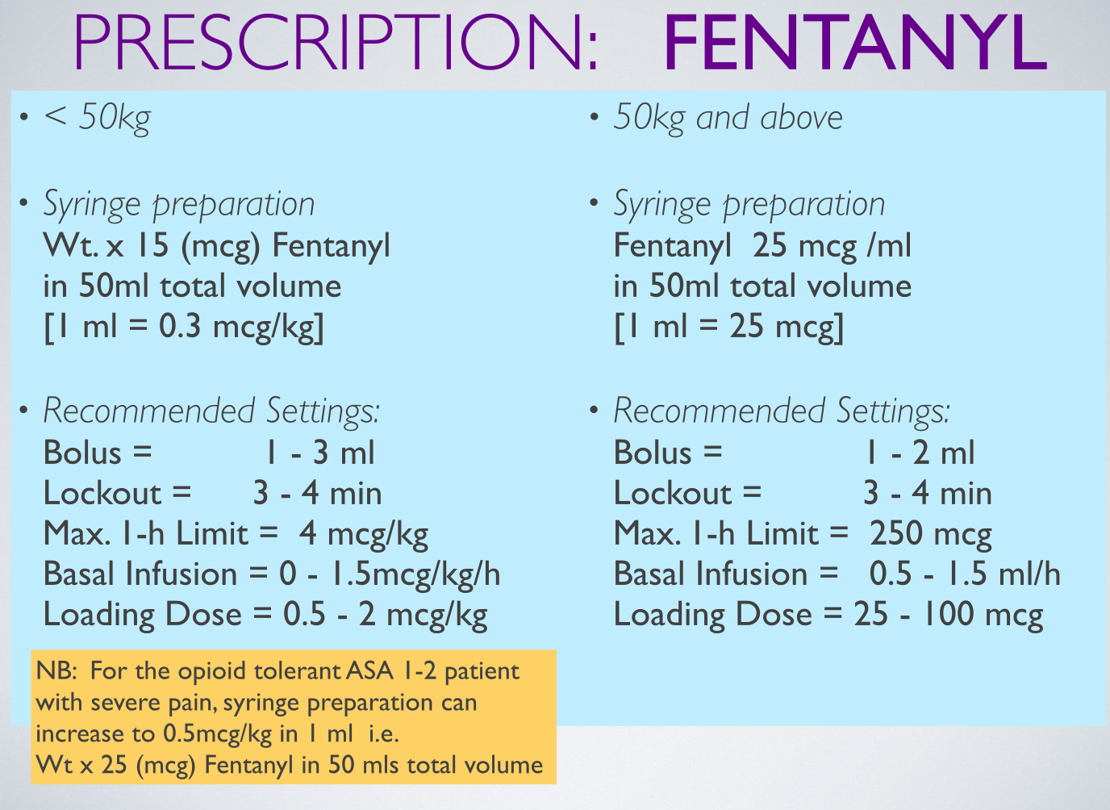

Monitoring & trouble-shooting

1. Inadequate analgesia

Check patient history from the pump.

If there are multiple unsuccessful attempts, increase the bolus and 1 h max *and* re-educate the child on PCA usage.

If a child has problems pressing the handset, a nurse or parent can help her with this. Perils of over administering should be indoctrinated appropriately.

The lockout interval may vary from 5 – 8 min but to NOT < 4min for morphine.

Dose increments are usually associated with increased side-effects.

NCA (NURSE CONTROLLED ANALGESIA) or AACA (Authorised Agent Controlled Analgesia)

The principles & charting are the same as for PCA. Programming is more conservative with strict instructions to press only if pain scores exceed 3-4.

* The lockout period is 10-15 min for morphine & 5-10min for fentanyl
* The maximum 1 h limit is set 20-25% lower
* Typically boluses are limited to no more than 4 per hour initially

**OPIATE INFUSIONS**

These follow the dichotomous weight-based PCA prescription; limits should not be exceeded; syringe boluses should not exceed 2 mls & require sufficient interval (15 min) for assessment of response.

**ULTRA LOW-DOSE KETAMINE INFUSIONS**

Indicated if :

* The pain is hard to control despite adequate opioids.
* Used to curb opiate tolerance
* Used improve quality of analgesia
* Reduces opiate requirements & thereby ameliorating

opioid induced hyperalgesia (OIH) & opiate side- effects

*Dilution:*

*It is recommended to use lockable PCA pump to prevent tampering)*

Thisis diluted as per morphine to create a 1ml/h = 20 mcg/kg/h

Generally patients are rational & not over sedated with infusions of

1 ml/h but some will complain of dizziness, excessive salivation, hallucinations & a dis-embodied feeling

**PCA KETAMINE**

Indicated if :

frequent intense pain or procedural intervention render

PCA opiate or opiate infusion ineffective.

*Dilution:*

*Body Weight (mg) in 50 ml N/S*

Low dose 1 ml /h = 20 mcg/kg/h

Lockout 10-15 min

Background not to exceed 1 ml/h

*Higher concentration or higher dose dilution*:

Body Weight x 5 (mg) in 50 ml ; 1ml/h = 100 mcg/kg/h

if require more intense sedation/ analgesia e.g. for dressing changes

provide more drug per bolus; keep infusion to < 1 ml/ h

**PCA KETAMINE-MORPHINE COMBINATION**

Indicated if: pain is hard to control despite adequate opioids.

*Dilution*: Both ketamine & morphine combined (1:1) into one PCA

Allow 4-5 presses per hour & increase lockout interval to 10-15 min.

Difficult to adjust dose if patient is intolerant to adverse effects of ketamine so a trial of a separate Low-dose Ketamine infusion allows more flexibility in dose adjustment

Other adjuncts:

Dexmedetomedine infusion

Clonidine (1 mcg/kg q6-8h IV / PO)

Gabapentin, Pregabalin

**Optimising good use of PCA modality**

Load opiate or dispense 2 -3 boluses if pain not well controlled

Educate on proper use: encourage pre-emptive 2 boluses before movement & Physiotherapy

Treat side-effects which may deter optimum use

Escalate analgesia by increasing bolus as well as being quick to add an analgesic adjunct

**Weaning & discontinuation**

PCAs are usually required for 2 - 3 days, but may be continued for much longer period if indicated e.g. in Oncology, Trauma & Burns, Scoliosis

Once the child is taking orally, start him / her on oral non-opiate analgesics q 6 - 8h (whilst still on the PCA). This will help with weaning the PCA & will provide better analgesia.

Convert the 24h opiate requirement to an oral opiate round the clock with PRN prescription of 10-20% of this amount. Either Mist morphine or Oxycodone (Oxynorm) make good conversions; sustained-release formulations & trans-dermal applications are neither suited to nor recommended for Acute Pain management.

Discontinue PCA when:

* Minimal use of bolus demands (Eg < 4-8 presses per 24h)
* Minimal 24h opiate requirement (Eg < 0.1-0.3 mg/kg morphine in 24h)
* Patient or surgeon request (providing pain is well controlled)

Drips may need to be re-sited if painful or inflamed.

Additional adjuncts may be required if pain is severe